MLA0105 - Artificial Intelligence and Expert System for Gaming

EXPERIMENT- 1: SLIDING PUZZLE (3 X 3)

from collections import deque
def print_puzzle(state):
for i in range(0, 9, 3):
print(state[i:i+3])
print()
def get_next_states(state):
moves = []
idx = state.index(0) # empty space (0)
directions = {
0: [1, 3],
1: [0, 2, 4],
2: [1, 5],
3: [0, 4, 6],
4: [1, 3, 5, 7],
5: [2, 4, 8],
6: [3, 7],
7: [4, 6, 8],
8: [5, 7]
}

for d in directions[idx]:
new_state = state[:]
new_state[idx], new_state[d] = new_state[d], new_state[idx]
moves.append(new_state)
return moves
def solve_puzzle(start, goal):
queue = deque([start])
visited = set()
parent = {tuple(start): None}

while queue:
curr = queue.popleft()

if curr == goal:
path = []
while curr:
path.append(curr)
curr = parent[tuple(curr)]
return path[::-1]

visited.add(tuple(curr))

for nxt in get_next_states(curr):
if tuple(nxt) not in visited:
parent[tuple(nxt)] = curr
queue.append(nxt)

return None

start_state = [1, 6, 5,
7, 3, 8,
4, 2, 0]

goal_state = [1, 2, 3,
4, 5, 6,
7, 8, 0]

solution = solve_puzzle(start_state, goal_state)

print("SOLUTION STEPS:\n")
for step in solution:
print_puzzle(step)

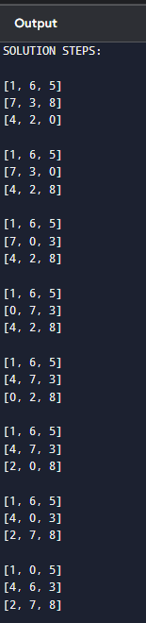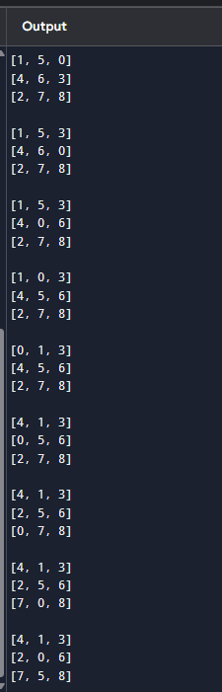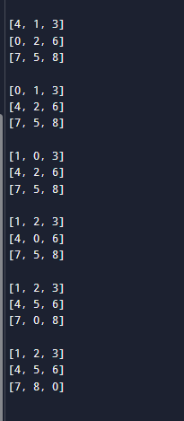

EXPERIMENT- 2:Towers of Hanoi problem

def towers_of_hanoi(n, source, temp, destination):
if n == 1:
print(f"Move disk 1 from {source} to {destination}")
return

towers_of_hanoi(n - 1, source, destination, temp)
print(f"Move disk {n} from {source} to {destination}")
towers_of_hanoi(n - 1, temp, source, destination)

n = 3
towers_of_hanoi(n, 'A', 'B', 'C')

